|  |  |
| --- | --- |
|  | **PRESS RELEASE** |

**CTIA prohibited a dangerous toy – a toll with braids, a keyring**

***(Prague, March 1, 2021)* The Czech Trade Inspection Authority found that there is a toy in the domestic market that can pose a health risk to the smallest children. It is a doll product with braids – keyring.**

The Czech Trade Inspection Authority found a product in the domestic market that can be dangerous for the smallest children. It is a plastic doll that has a chain with a key ring attached to the back of its head. The doll is dressed in a dress of different colours, on which various coloured fabric flowers are attached. It has removable plastic booties on its feet. The product is distributed without packaging and no information is provided to the consumer.

By conducting appropriate tensile strength tests, it was found that by force (55 N), metal parts - the chain and the key ring that fit in the cylinder for small parts - were released from the product. Lightly removable plastic booties also fitted in the cylinder for small parts.

It is a product with a dual function - it is also a keyring and a toy without any indication of the age of the child fr which i tis intended. The manufacturer does not draw attention to any risk to children under the age of three that may be associated with the product. The product does not comply with the requirements of the Government Order No. 86/2011 Coll., on Toys Safety, as specified in ČSN EN 71-1+A1:2019 Toy Safety – Mechanical and Physical Properties. While using the toy, a small child can remove the dolls‘ booties, or tear off the above small parts from the toy, which they can swallow or inhale.

The Czech Trade Inspection Authority imposed a protective measure on the distributor of the toy, consisting of a ban on the distribution and withdrawal of the product from the market or from circulation. The toy was reported to the contact point at the Ministry of Industry and Trade and published in RAPEX.

**Product information:**

Product name: Panenka s copánky v šatech  
Trademark: Not displayed  
Type / model number: Not displayed   
EAN: Not displayed  
Manufacturer identification data: Not displayed  
Importer identification data: Not displayed

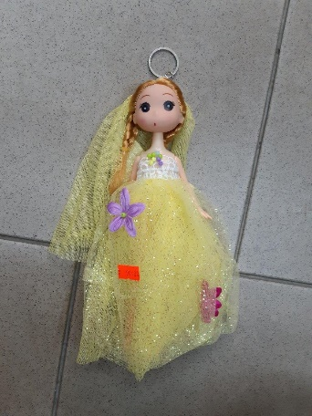

Picture of the product



Detected defects of the toy after tense strenght tests