PRESS RELEASE

In 2020, CTIA notified nine dangerous toys into alert system RAPEX
(Prague, March 4, 2021) The Czech Trade Inspection Authority has monitored the safety of toys for a long time. Last year, it inspected 2,767 toy models and found mostly administrative shortcomings in 979 cases. It assessed 9 models of toys as dangerous. „In such cases, the analyses carried out showed a serious risk of possible injury or health consequences due to long-term user contact with substances that may pose a health risk to the organism of little children. Toy inspections will continue in the next period. Increased attention will also be paid to the search for dangerous toys that were published in RAPEX by other EU Member States," says the CTIA Director Mojmír Bezecný on the results of the inspections.
During 2020, the Czech Trade Inspection Authority inspected the compliance with the Act No. 22/1997 Coll., on Technical Requirements for Products. Specifically, these were toys for children aged 0 to 14. The total of 909 toy inspections were carried out by 14 manufacturers, 22 importers to the EU and 873 distributors. During these inspections, CTIA officers inspected 2,767 toy models and found mostly administrative deficiencies in 979 models. The flaws were often repeated. Some toys also accumulated several of the following administrative defects:
• 117 shortcomings in the mandatory identification of the toy type, serial number or model;
• 596 shortcomings in the identification of the toy manufacturer
• 371 shortcomings in the identification of the importer
• 297 shortcomings in the accompanying documentation (missing warnings, instructions or warnings in the Czech language)
• 286 shortcomings in the accompanying documentation (completely missing warnings, instructions or warnings)
During 2020, the Czech Trade Inspection Authority assessed a total of 9 toy models as dangerous due to mechanical defects, the content of prohibited chemicals or small parts released from toys. In all cases, the risk analyses carried out showed a serious risk of possible injury or health consequences due to long-term contact with substances that may pose a health risk to the developing organism of young children. Information on the presence of non-compliant toys in the market was published in RAPEX. The consumer warning was published on the CTIA website: https://www.coi.cz/pro-spotrebitele/rizikove-vyrobky/

Dangerous toys 2020

Name |  | Published on www.coi.cz
Ryba plyšová s přísavkou |  | https://www.coi.cz/nebezpecna-hracka-plysaky/ | 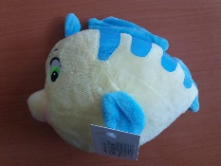
Drak Čmoudík zpívající |  | https://www.coi.cz/nebezpecna-hracka-zpivajici-drak/ | 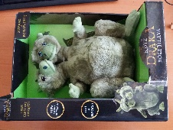
Veverka se zvukem |  | https://www.coi.cz/veverka-se-zvukem-znamena-pro-nejmensi-deti-riziko/ | 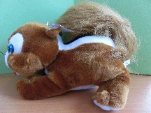
Dřevěné chrastítko |  | https://www.coi.cz/coi-zakazala-na-trhu-nebezpecne-chrastitko-pro-deti/ | 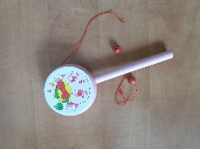
Sliz Jun Tao |  | https://www.coi.cz/sliz-obsahoval-nadlimitni-mnozstvi-boru/ | 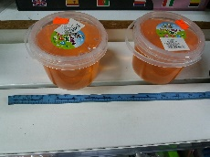
Pryžové strašidýlko se šňůrou |  | https://www.coi.cz/i-v-dobe-prvni-vlny-epidemie-coi-kontrolovala-bezpecnost-hracek/ | 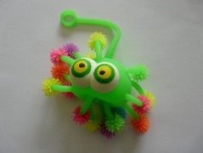
Kočárek golfky |  | https://www.coi.cz/coi-zakazala-hracku-doll-carrier/ | 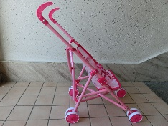
Panenka ROSE |  | https://www.coi.cz/nebezpecna-panenka-pro-deti-do-3-let/ | 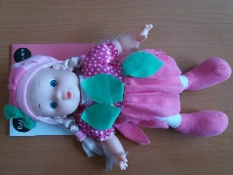
Houpačka s ohrádkou barevná |  | https://www.coi.cz/coi-zakazala-na-trhu-detskou-houpacku-swing-with-backrest/ | 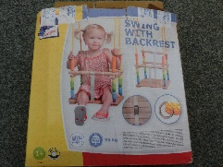

Imposed measures

In 2020, the Czech Trade Inspection Authority imposed the total of 339 fines amounting to the total of CZK 2,722,500 for breaches of § 13 para. 9 of Act No. 22/1997 Coll., on Technical Requirements for Products.

