Brussels, February 2023

JAHARP2020-2 – First Newsletter

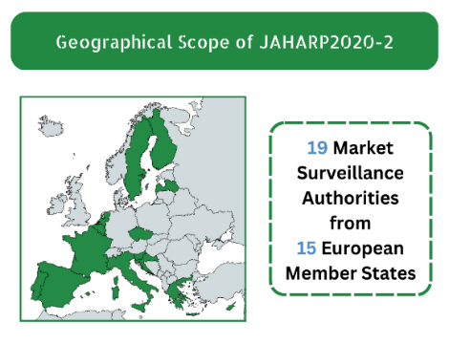
19 Market Surveillance Authorities (MSAs) from 15 European countries work jointly to keep European consumers safe.
How safe are your products?

JAHARP2020-2 chose specific product categories and performed documentary checks and tests to assess their safety and compliance with the European legislation. We are checking 30 tumble dryers, 195 IoT Connected Devices, and 80 non-refillable helium cylinders. All non-compliant products would require follow-up measures by the European Market Surveillance Authorities (MSAs).

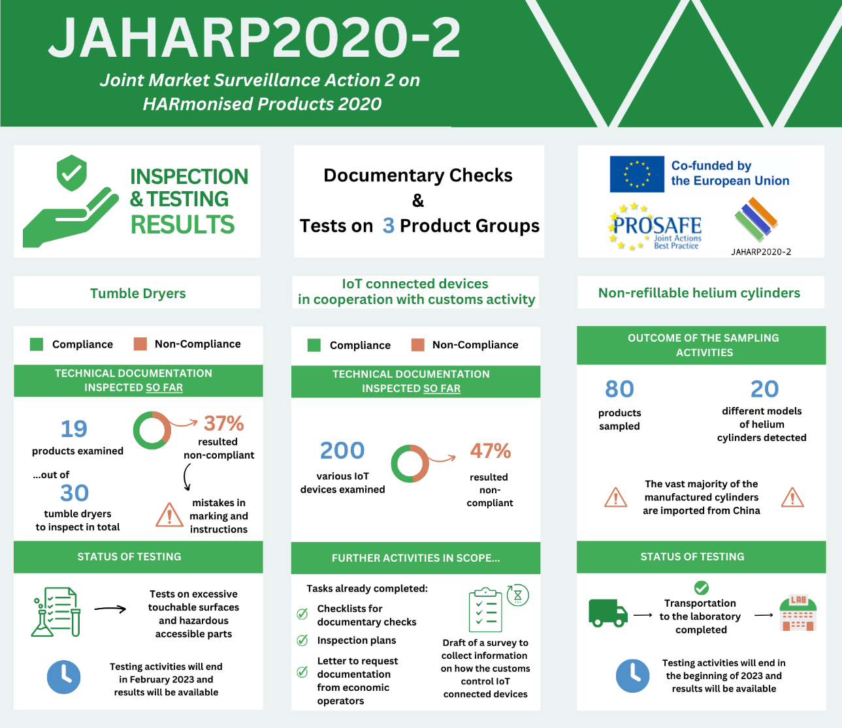
The JAHARP2020-2 is a 24-month pan-European Triplet Project co-funded by the European Union (EU). Its strategic objective is threefold: (i) to raise the level of market surveillance; (ii) to facilitate the application of the new Market Surveillance Regulation (EU) 2019/1020; and (iii) to increase the capability of the European MSAs. The project is coordinated by PROSAFE - The Product Safety Forum of Europe, a non-profit NGO formed by market surveillance officers and based in Brussels.

Overview of the state of play per working group

Tumble dryers

Almost 20% of fire-related incidents involving kitchen appliances in the UK since 2012 concern tumble dryers. Given these hazards and risks, the project group has decided to verify the compliance and safety for these products and sampled 30 tumble dryers that were sent to the selected testing laboratory. At present, the lab had performed checks on markings and instructions on 19 appliances of the 30 that are in the programme. So far 7 out of these 19 (37%) are proven not compliant with the requirements. The testing for excessive temperatures of touchable surfaces and other hazardous accessible live parts is completed for several samples, and the results are under evaluation. In parallel with testing, the MSAs are completing the templates for the product checklists and reviewing the technical documentation. The evaluation requirements for the ‘connected’ tumble dryers within the scope of the Radio Equipment Directive were developed in collaboration with the working group dealing with IoT connected devices.

IoT connected devices in cooperation with customs activity

The high level of sophistication and the great proliferation of the Internet of Things (IoT) connected devices prevent the creation of qualified standards for them, which also makes the market surveillance work more difficult. To tackle the challenges, the MSAs chose to carry out documentary inspections for these products together with the customs authorities. The group determined the aspects to investigate, and produced detailed checklists for documentary checks and markings, as well as inspection plans for IoT connected devices of several product types. The administrative assessment is still ongoing, and some preliminary results are available. So far, the group has performed checks for 200 products. Out of these, 94 products (47%) presented administrative non-compliances. The MSAs have also drafted and sent a common template letter to request the relevant documentation from relevant economic operators. Furthermore, the group started to prepare a survey to collect information on how the customs authorities perform checks and collaborate with MSAs for these devices.

Non-refillable helium cylinders

Non-refillable helium cylinders are popular among consumers (in particular, with children) for inflating balloons at parties. Hence, there are stringent TPE requirements due to the possible risks such as the accidental release of gas (potentially leading to hypoxia or, in the worst-case scenario, suffocation), the burst of a defective cylinder, and the failure of a valve that can injure people nearby. Following some preliminary research, the project group identified 20 different models of cylinders on the market (most of them imported from China while only few manufactured in Europe) and sampled 80 products (4 specimens for each model) to send to the selected test laboratory. Testing activities started and will be completed in early 2023.

Communication and Outreach

PROSAFE’s web portal www.prosafe.org and social media (Twitter and LinkedIn) keep the target audiences regularly updated with news on the project progress thanks to effective communication complemented by infographics and visuals. The status of the activities was also communicated in other forms, e.g., presentations at the TPED AdCo group on 10 June 2021, at the LVD AdCo Group on 16 November 2021, at the RED AdCo group on 23 March 2021, and at the PROSAFE General Assembly organised on 31 May 2022.

Contact us:
Ioana Sandu, Executive Director, PROSAFE Office, Avenue des Arts/Kunstlaan 41, B-1040 Brussels, Belgium Tel: +32 2 8080 996, info@prosafe.org / www.prosafe.org, @PROSAFE_ORG

