Brussels, February 2023

JAHARP2020-3 – First Newsletter

22 Market Surveillance Authorities (MSAs) from 21 European countries work jointly to keep European consumers safe.
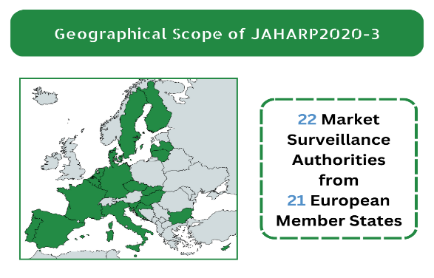
How safe are your products?

JAHARP2020-3 chose specific product categories and performed documentary checks and tests to assess their safety and compliance with the European legislation. We are checking 28 gas-fired space heaters, and 120 USB chargers. Also, we are developing a harmonised approach to market surveillance of large TPE (tanks) for the transport of class 2 gases. All non-compliant products would require follow-up measures by the European Market Surveillance Authorities (MSAs).

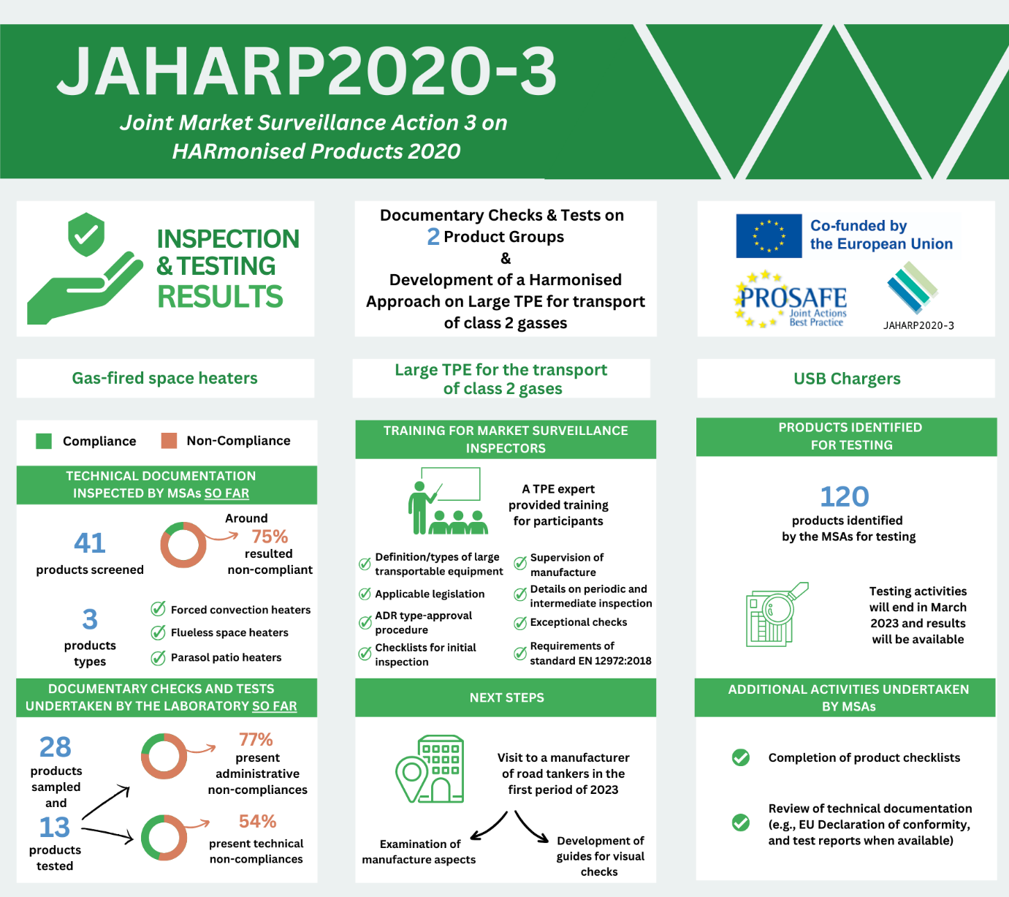
The JAHARP2020-3 is a 24-month pan-European Triplet Project co-funded by the European Union (EU). Its strategic objective is threefold: (i) to raise the level of market surveillance; (ii) to facilitate the application of the new Market Surveillance Regulation (EU) 2019/1020; and (iii) to increase the capability of the European MSAs. The project is coordinated by PROSAFE - The Product Safety Forum of Europe, a non-profit NGO formed by market surveillance officers and based in Brussels.

Overview of findings per working group

Gas-fired space heaters

Gas-fired space heaters are common in the EU – especially in the Western and Northern areas. Generally, such appliances present serious hazards such as risks of fire, burns, generation of CO (carbon monoxide), and electric shocks. To ensure the safety of these products, the project group is currently checking the technical documentation for some heaters. Up to now, the participants inspected the technical documentation for 41 products (i.e., declaration of conformity, type approval certificates, and proof for production control), with around 75% presenting administrative non-compliance. Based on this preliminary screening, the group identified 28 samples to send further to an accredited test laboratory. The laboratory found that 10 products out of the 13 products that have been examined so far present administrative non-compliances (e.g., marking errors, errors in the user instructions, etc.), and 7 samples out of the 13 checked pose possible technical issues that would make the products unsafe.

Large TPE for the transport of class 2 gases

This project is a preparatory, capacity building activity, aimed at developing a harmonised approach to market surveillance of large TPE (tanks) for the transport of class 2 gases. If tanks designed for the transport of these gases are exposed to high stresses (e.g., extreme temperatures, road or rail accidents), they may release the toxic or inflammable gases they contain – thus representing serious hazards for the environment and all vehicles and persons in the vicinity. To help improve the market surveillance for this sector, the project selected a TPE expert to prepare checklists and provide training for inspectors. Training included the definition and types of large transportable equipment, applicable legislation, the ADR type-approval procedure and checklists for initial inspection, supervision of manufacture, periodic and intermediate inspection, exceptional checks, and the requirements of standard EN 12972:2018. In end of January 2023, the group will arrange a study visit in Slovenia, i.e., a visit to a manufacturer of road tankers to examine aspects of manufacture and inspection of the equipment, with a view to developing guides to visual checks.

USB Chargers

The initial risk analysis revealed that 96 EU Safety Gate Alerts issued since 2015 exposing risks of electric shock, fire and burn hazards are associated with direct plug-in USB chargers. Users frequently charge electronic devices overnight with an increased risk of the connected device and the charger overheating. The project group intends to raise the overall safety level of these products and selected 120 USB chargers for testing. The contracted testing laboratory will provide regular testing status updates. Product testing is expected to end in March 2023. In parallel with the testing activity, the MSAs are completing product checklists and reviewing technical documentation, including the EU Declaration of Conformity and test reports where applicable. The evaluation requirements are based on conformity assessment provisions of the EU Low Voltage Directive 2014/35/EU.

Communication and Outreach

PROSAFE’s web portal www.prosafe.org and social media (Twitter and LinkedIn) keep the target audiences regularly updated with news on the project progress thanks to effective communication complemented by infographics and visuals. The status of the activities was also communicated in other forms, e.g., presentations at the TPED AdCo group on 10 June 2021, at the LVD AdCo Group on 16 November 2021, at the GA AdCo group meetings on 21 April 2021 and 15 June 2022, and at the PROSAFE General Assembly organised on 31 May 2022.

Contact us:
Ioana Sandu, Executive Director, PROSAFE Office, Avenue des Arts/Kunstlaan 41, B-1040 Brussels, Belgium Tel: +32 2 8080 996, info@prosafe.org / www.prosafe.org, @PROSAFE_ORG

