Brussels, April 2023

JAHARP2020-1 Newsletter (second edition)

24 Market Surveillance Authorities (MSAs) from 20 European countries work jointly to keep European consumers safe
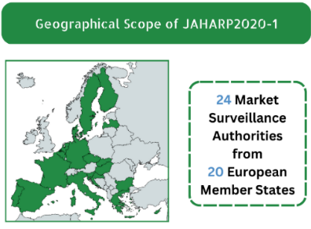
Our goal: the safety of your products

JAHARP2020-1 performed documentary checks and tests on consumer products to assess safety and compliance with European legislation. By May 2023, we will test 27 gas cooking hobs and the Specific Absorption Rate of 30 models of connected portable devices. Additionally, we have devised a harmonised approach for assessing the administrative requirements for 6 product-related Directives.

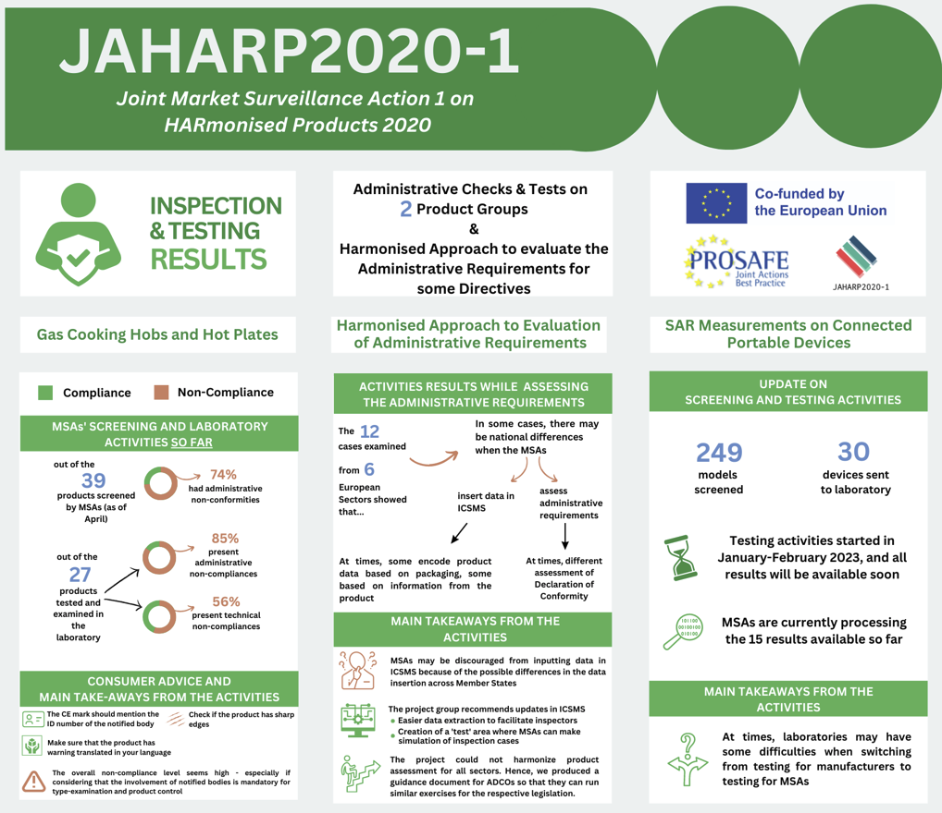

The JAHARP2020-1 is a 24-month pan-European Triplet Project co-funded by the European Union (EU). Its strategic objective is threefold: (i) to raise the level of market surveillance; (ii) to facilitate the application of the new Market Surveillance Regulation (EU) 2019/1020; and (iii) to increase the capability of the European MSAs. The project is coordinated by PROSAFE - The Product Safety Forum of Europe.

Project results per working group

Gas cooking hobs and hot plates
The participating MSAs screened 39 gas cooking appliances and selected 27 products for testing by an accredited test laboratory. According to the results to date, 23 (85%) of the 27 samples showed some kind of administrative non-compliance. 15 (56%) of the appliances were found to have technical nonconformities. These include appliances with sharp edges, release of unburned gas, burners deforming during use leading to an imperfect burning behaviour, interrupted gas supply in case the appliance is tilted, and touchable surfaces that become too hot during use.

Harmonised Approach to Evaluation of Administrative Requirements
The group worked on 12 case studies across 6 legislations (RED, LVD, EMC, GAR, TPED, PED). The goal was to increase the harmonisation level in the assessment of the administrative requirements and the use of the EU’s Information and Communication System for Market Surveillance (ICSMS) to improve data comparability. Each participant first recorded the product cases in ICSMS. In step two, all recorded cases were extracted and analysed to compare the inputs. The review showed that in some cases MSAs may have different approaches when evaluating the administrative requirements. For example, differences were observed in the examination of the Declaration of Conformity and in the recording of data in ICSMS—e.g., while some MSAs encoded data related to the product ID from the packaging, others did it from the product itself. To reduce inconsistency, the group developed tooltips and guidance documents, together with actionable recommendations for future adaptations of ICSMS.

The Specific Absorption Rate (SAR) Measurements on Connected Portable Devices
A total of 249 models of connected portable devices was screened. 30 products were shortlisted and sent for laboratory testing to measure their SAR in line with the provisions of Recommendation 1999/519/EC on the limitation of exposure of the general public to electromagnetic fields (0 Hz to 300 GHz). Testing activities are ongoing and are expected to be finalised in the next few weeks. Participating MSAs are currently processing 15 test reports that have been released, so far, by the test laboratory to determine the necessary follow-up actions.

Consumer advice and key take-aways
- Check the CE mark and make sure it mentions the 4-digit ID number of the Notified Body involved in the production control of your gas cooking hob.
- Ensure that cooking hobs have no sharp edges.
- Make sure that your product contains warnings translated in your language.
- The non-compliance rate throughout the project activities was surprisingly high – considering that it is mandatory to involve a Notified Body in the type-examination and the production control.
- Inconsistencies in evaluating the administrative requirements prevent benchmarking and analysis of the ICSMS data. The current scenario may discourage MSAs from inputting information into the system because they would not see the benefits.
- ICSMS future development should include an easier data extraction and a ‘test’ environment where MSAs can simulate the input of different cases for comparison or review by other inspectors.
- Guidance was produced for AdCos to help MSAs run similar exercises for their applicable legislation. Since the project group cannot harmonise the requirements assessment for all types of products, AdCos can do it for their respective sector.
- At times, laboratories may have issues when switching from testing for manufacturers to that for MSAs.

Communication and Outreach
PROSAFE’s web portal www.prosafe.org and social media (Twitter and LinkedIn) provide progress updates to the public, also through infographics and visual content. Progress was also communicated via presentations at the TPED AdCo group meeting on 10 June 2021 and the PROSAFE General Assembly on 31 May 2022.
Contact us: Ioana Sandu, Executive Director, PROSAFE, Avenue des Arts/Kunstlaan 41, 1040 Brussels, Belgium, +32 2 757 9336, info@prosafe.org

