Brussels, April 2023

JAHARP2020-2 Newsletter (second edition)

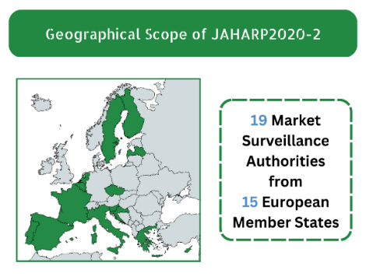
19 Market Surveillance Authorities (MSAs) from 15 European countries work jointly to keep European consumers safe
Our goal: the safety of your products

JAHARP2020-2 performed documentary checks and tests on consumer products to assess safety and compliance with European legislation. By May 2023, we will finalise checks on 30 tumble dryers, 200 Internet of Things (IoT) connected devices, and 76 non-refillable helium cylinders (19 models, 4 specimens per model). Enforcement actions are being taken by the responsible MSAs against all non-compliant products.

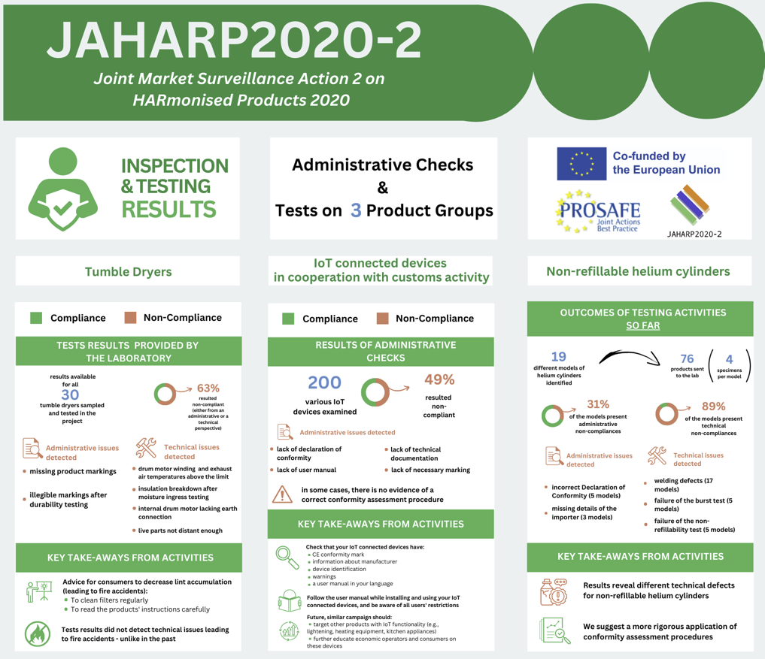

The JAHARP2020-2 is a 24-month pan-European Triplet Project co-funded by the European Union (EU). Its strategic objective is threefold: (i) to raise the level of market surveillance; (ii) to facilitate the application of the new Market Surveillance Regulation (EU) 2019/1020; and (iii) to increase the capability of the European MSAs. The project is coordinated by PROSAFE - The Product Safety Forum of Europe.

Project results per working group

Tumble dryers
Product testing is completed for all 30 samples of tumble dryers. Results have been prepared and test reports have been sent to the participating MSAs. Nonconformities have been identified in 19 (63%) of the products. These include missing product markings and illegible markings after the durability test, drum motor winding temperatures above allowable limits, exhaust temperature of the air from the drum above allowable limits, insulation breakdown after moisture ingress testing, lack of earth connection for the internal drum motor and internal distances between live parts below allowable limits. Risk assessments are underway, with the initial evaluation suggesting that while most nonconformities present a medium risk of injury, some seem to pose a high risk to consumers. The group is currently reviewing the technical documentation for the four ‘connected’ tumble dryers within the scope of the Radio Equipment Directive (RED).

IoT connected devices in cooperation with customs activity
The most updated -but not final- results revealed that 98 (49%) of the 200 products checked had administrative nonconformities. These involve the absence of the EU Declaration of Conformity, technical documentation, user manual, or necessary marking. A lack of evidence that a conformity assessment procedure of the radio equipment is carried out in accordance with the provisions of RED raises reasonable suspicion that this non-compliant radio equipment is liable to affect the operation of the products, the safety of the end-users, as well as the operation of other equipment, including the security of consumer data. Enforcement actions are ongoing. Lastly, the group has also prepared a survey to collect information on how the Customs perform checks and collaborate with MSAs for IoT connected devices.

Non-refillable helium cylinders
19 models were sampled from the market and tested by an accredited laboratory. Out of these 19 models, 14 showed some kind of administrative non-compliance, while 17 showed some kind of technical non-compliance. Several anomalies were found relating to traceability requirements. Specifically, 6 declarations of conformity were incorrect, while 5 products lacked the name and address of the importer. Tests have been carried out on 4 samples for each selected model. 17 of the 19 models showed defective welding, 5 failed the burst test, and 5 failed the non-refillability test. These defects are liable to affect the safety of consumers. The results and risks involved are being analysed by the MSAs in order to determine the necessary corrective measures.

Consumer advice and key take-aways
- In the past years, construction and lint accumulation issues in tumble dryers led to fire accidents. Now, test results did not detect these defects, thus suggesting an improvement in the appliances safety.
- Regularly clean the appliance filter and follow the manufacturer’s instructions to decrease the lint quantity.
- Ensure that your IoT connected devices are provided with the CE conformity mark, information about manufacturer, the device identification, the necessary warnings, and a user manual in your language.
- Be aware of the restrictions on the use of your IoT connected devices (this information is in the manual).
- Strictly follow the user manual while installing and using your IoT connected device.
- Similar campaigns should be considered in the future also targeting different products with IoT functionality, especially those that historically did not represent radio equipment (e.g., kitchen, lightening, heating equipment etc.).
- Campaigns increasing economic operators’ and consumers’ education on these devices are important.
- Results revealed several technical issues and suggest the need for a more rigorous application of the conformity assessment procedures.

Communication and Outreach
PROSAFE’s web portal www.prosafe.org and social media (Twitter and LinkedIn) provide progress updates to the public, also via infographics and visuals. The status of the activities was also communicated in other forms, e.g., presentations at the TPED AdCo group on 10 June 2021, the LVD AdCo Group on 16 November 2021, the RED AdCo group on 23 March 2021, and at the PROSAFE General Assembly on 31 May 2022.
Contact us: Ioana Sandu, Executive Director, PROSAFE, Avenue des Arts/Kunstlaan 41, 1040 Brussels, Belgium, +32 2 757 9336, info@prosafe.org

