Brussels, April 2023

JAHARP2020-3 Newsletter (second edition)

22 Market Surveillance Authorities (MSAs) from 21 European countries work jointly to keep European consumers safe
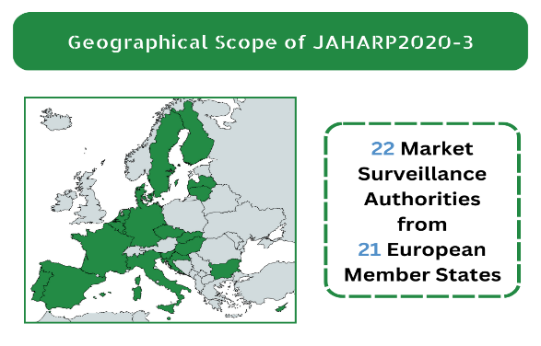
Our goal: the safety of your products

JAHARP2020-3 performed documentary checks and tests on consumer products to assess safety and compliance with European legislation. By May 2023, we will have checked and tested 31 gas-fired space heaters and 120 USB chargers and follow-up measures against all non-compliant products will be finalised. JAHARP2020-3 has also developed a harmonised approach to market surveillance of large TPE (tanks) for the transport of class 2 gases.

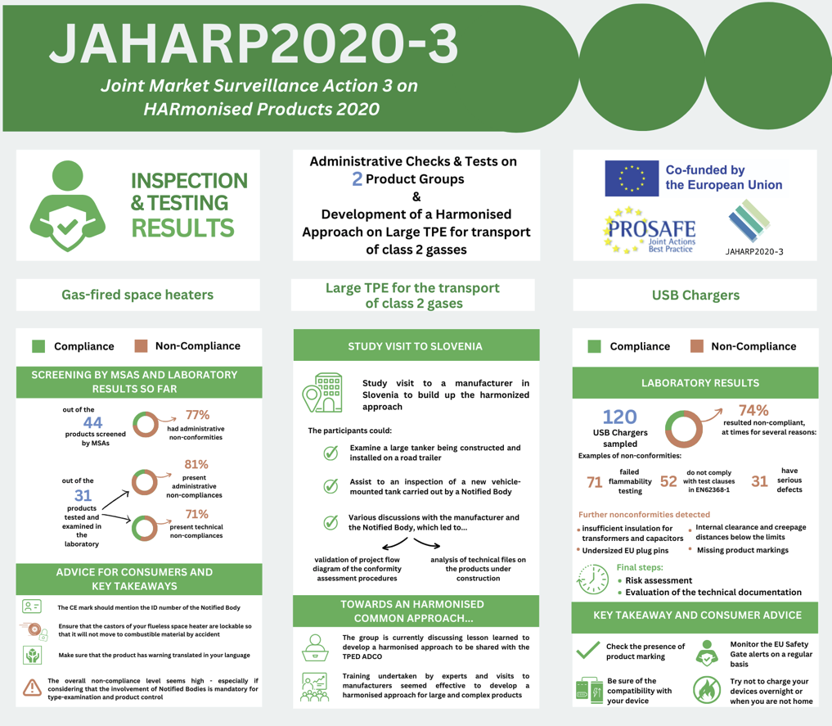
The JAHARP2020-3 is a 24-month pan-European Triplet Project co-funded by the European Union (EU). Its strategic objective is threefold: (i) to raise the level of market surveillance; (ii) to facilitate the application of the Market Surveillance Regulation (EU) 2019/1020; and (iii) to increase the capability of the European MSAs. The project is coordinated by PROSAFE - The Product Safety Forum of Europe.

Project results per working group

Gas-fired space heaters
After screening 44 gas-fired space heaters, the participating MSAs selected 31 models and sent them for testing to an accredited test laboratory. The most updated results suggest that 25 of the 31 appliances exhibited administrative non-compliances, including marking errors or errors in the user instructions. Furthermore, technical nonconformities were found in 22 of the 31 tested models so far. These include hot surfaces exceeding the temperature limits, wrong flame behaviour (i.e., flames taking a long time to ignite in the burner), non-lockable castors in case of flueless heaters, and products not extinguishing when the level of CO₂ in the room exceeds the limit.

Large TPE for the transport of class 2 gases
In the last phase of this capacity-building activity, the group organised a study visit to a manufacturer of road tankers in Slovenia in January 2023 and witnessed the last stages of the inspection of a new vehicle-mounted tank by a Notified Body (i.e., an air-tightness test). Discussion with the representatives of the manufacturer and the Notified Body enabled the participants to validate the flow diagram of the conformity assessment procedures of the project and to examine the technical files relating to the products under construction. The group is now consolidating the lessons of these activities with a view to developing a harmonised approach that will be made available to all TPED ADCO members.

USB Chargers
Laboratory testing is completed for all 120 USB chargers sampled by the participating MSAs. Nonconformities have been identified in 89 (74%) of the products checked. These include missing product markings, undersized EU plug pins, internal clearance and creepage distances well below the limits permitted, and insufficient electrical insulation for transformers and capacitors. Furthermore, 71 of the products (59%) failed flammability testing implying inadequate protection against the spread of fire (i.e., faulty fire enclosures or fire barriers). Out of the 120 products, 52 (43%) had multiple nonconformities against test clauses in EN 62368-1. Overall, tests revealed serious defects for 31 USB chargers (26%). Risk assessment, the evaluation of the technical documentation, and enforcement actions are underway.

Consumer advice and key takeaways
- Check the CE mark. It must mention the 4-digit ID number of the Notified Body involved in the production control.
- If you want to buy a flueless space heater, look for a model where the castors are lockable to avoid that the heater slides towards combustible material while operating.
- Check that the product comes with warnings in your own language.
- Non-compliance levels are high even if Notified Bodies should be part of type-examination and production controls
- Training serviced by technical experts and hands-on exchanges with manufacturers proved to be useful to develop a harmonised approach to market surveillance for large and complex products.
- Check that your USB charger plugs in easily and ensure correct product markings and compatibility with your device(s); check the EU Safety Gate alerts for dangerous products regularly; where possible, avoid charging devices overnight or when leaving your home.
- Although USB chargers are now commonplace, they seem to continue to pose electric shock and fire risks.
- The sampling process was effective: MSAs were successful in identifying unsafe products from online descriptions.

Communication and Outreach
PROSAFE’s web portal www.prosafe.org and social media (Twitter and LinkedIn) provide progress updates to the public, also via infographics and visuals. The status of the activities was also communicated in other forms, e.g., presentations at the TPED AdCo group on 10 June 2021, the LVD AdCo group on 16 Nov. 2021, the GA AdCo group meetings on 21 April 2021 and 15 June 2022, as well as at the PROSAFE General Assembly on 31 May 2022.

Contact us: Ioana Sandu, Executive Director, PROSAFE, Avenue des Arts/Kunstlaan 41, 1040 Brussels, Belgium, +32 2 757 9336, info@prosafe.org

